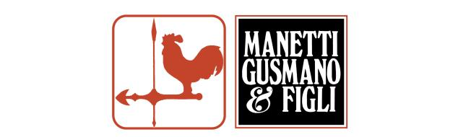

ORCI DA VINO
referenze

ITALIA
Dianella da Vinci
Kornell
Zamò
Cantina Merano
La Valentina
Argiolas
Poggio al Tesoro
Egger
Tuarita
Fontodi
Podernovo
Enrico Rivetto
Cappella Sant'Andrea
Castello di Albola
Frescobaldi
Il Borro
Le Pupille
La Ginestra
Tenimenti Luigi D'Alessandro
Petrolo Società Agricola
Mazzei
Tenute Lunelli
Duemani
Istine
Fontuccia – Senti Oh
Tolaini
Saint Roch
Feudo Maccari
Podernovo

USA
Continuum
Blackbird Vineyards
Fernray LLC
Rudd
Perliss Vineyard
Pott Wine
Turnbull Wine Cellars
Brand Napa Valley
Failla Wines
Somnium
Beaux Freres
Matt Naumann
Dumol
L’Aventure
Big Basin
Continuum
Laura Ambroseno
Futo Wines
Desparada Wines
Buccella
BN Wines
Hundred Suns Wine
Marie-Laure Ammons
Stoller Family Estate
Domaine Roy & Fils

SUD AFRICA
Grande Provence
Haute Cabriere
Baleia Bay
Jansen
Haskell
Longridge
Orange River
Lourensford
Kleine Zalze
Druk My Niet
Cape Point Vineyards
Hartenberg
Asara
Benguela Cove
Nederburg
Bellingham
Boschendal
Avondale
Bizoe Wines
Guardian Peak
Jordan Wine Estate

FRANCIA
Chateau Laroze
Domaine Gangloff

AUSTRIA

Weingut Rucker
Firma K&G Strauss
Weingut Felberjorgl
Weingut Adrian Hartmann
Weingut Stefan Pfeiffer
Regele
Masser

GERMANIA

Firma
Weingut Schmucker
Johanninger

AUSTRALIA
Cullen
Paul Nelson
Skigh
Glenarty
Symphony Hill

NUOVA ZELANDA
Matavino
Marisco
Hans Herzog
Rockeferry

